 | Abdi İpekçi Caddesi Kaşıkçıoğlu Apt. No:46 D:2 34365 Nişantaşı İstanbul  www.artxist.com  info@artxist.com  T. +90 212 291 77 84 F. +90 212 343 69 35 | PRESS RELEASE

4th solo exhibition of Ansen at x-ist
THE TRACE
Between 16th of April and 16th of May, x-ist will host the 4th solo exhibition of Ansen, following his exhibitions "x-ist-ence" (2004), "Resistance" (2005) and "Menace" (2008).

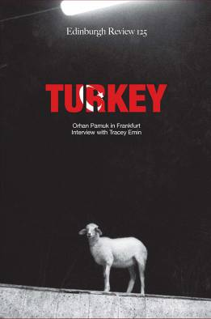

Ansen's experimental works, born through an interaction of sculpture, photography, cinema and music; presents us with a new and distinctive approach to painting. In this manner, it could be regarded to distance itself from a classic formalist tradition.

His works carry traces of a harmonic, multilingual structure underlining his truly unique vision. These hidden forms and thoughts borrowed from daily objects take their place in his works almost like the readings of an overly eloquent fortune teller.

He follows a trail of past experimentation without conceding to an analysis of form or even a method of expression. By doing so, his works become 'polyphonic', expanding the visual and conceptual perspective of the viewer.

One could regard "The Trace" as a window into the future of Ansen's works, containing a structure that makes it possible for the viewer to 'discover', without being bludgeoned by over-description.

Ansen states that sustaining his experimental production is a source of motivation for improving original methods. He makes clear that the logic behind the formation of his exhibition "The Trace" is not to "arrive" to a similar point but to discover new lands through a similar process.

Ansen:
Ansen was born in Kayseri, 1978. He is graduated from Mimar Sinan University Fine Arts Faculty, Painting Department. His works were exhibited in group exhibitions at Berlin Municipal Palace-Germany, Siemens Art, Contemporary İstanbul, China International Gallery Exposition, artfair06-Germany. His solo exhibitions; “x-ist-ence” (2004), “Resistance” (2005) and “Menace” (2008) were hosted by x-ist.

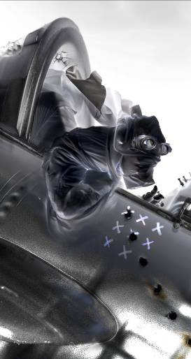
Opening: April 16, 2009, 18:00
Exhibition Dates: April 16 – May 16, 2009

